----------------------
🔹 Slide 1 – Task Analyses
This slide only introduces the topic.
Meaning:
- Task Analysis means studying what users do, how they do it, and in what order.
- It helps in designing better and easier systems.
📌 Used in Human Computer Interaction (HCI) and Usability Engineering.
----------------------
🔹 Slide 2 – What is Usability?
Usability means how easy a system is to use.
It has two main parts:
1️⃣ For new users
- Interface should be easy to learn
- Beginners should understand quickly
2️⃣ For experienced users
- Interface should be:
  - Efficient (fast)
  - Flexible
  - Powerful
📌 Usability is achieved through Usability Engineering (a proper design process).
----------------------
🔹 Slide 3 – Benefits of User-Friendly Products
When a system is usable, we get:
- Higher productivity
- Less training time & cost
- Fewer user mistakes
- More accurate data
- Less technical support
- More profit
- Lower development & maintenance cost
- Happy customers → more business
📌 Simple idea:
Good usability = success
----------------------
🔹 Slide 4 – Usability Engineering Lifecycle
There are two phases:
🔹 Phase 1 (Planning & Analysis)
- Identify users
- Analyze tasks
- Set usability goals
- Understand platform limits
- Follow design rules
🔹 Phase 2 (Implementation)
- Design the system
- Test it
- Develop it
📌 Task Analysis happens in Phase 1
----------------------
🔹 Slide 5 – What is Task Analysis?
Definition:
Task Analysis means studying:
- What people do
- What objects they use
- What knowledge they need
📌 It focuses on real work, not guesses.
----------------------
🔹 Slide 6 – Example: Cleaning a House
Task is broken into steps:
- Take out vacuum cleaner
- Attach tools
- Clean rooms
- Empty dust bag when full
- Put everything back
Also user must know:
- How vacuum works
- What attachments are
- Which rooms to clean
📌 Shows tasks = actions + knowledge
----------------------
🔹 Slide 7 – Approaches to Task Analysis
There are three main approaches:
1️⃣ Task Decomposition
- Break big task into small steps
2️⃣ Knowledge-Based Techniques
- Focus on what the user knows
3️⃣ Entity/Object-Based Analysis
- Focus on:
  - People
  - Objects
  - Relationships
----------------------

🔹 Slide 8 – Task Decomposition
Purpose:
- Describe actions
- Organize them into hierarchy
- Show task order
🔹 Most common method:
👉 Hierarchical Task Analysis (HTA)
📌 HTA is very important for exams.
🔹 Slide 9 – Textual HTA Example
Task: Clean the house
- Main task (Level 0)
- Subtasks (Level 1, 2, 3…)
Hierarchy description ...
0. in order to clean the house
1. get the vacuum cleaner out
2. get the appropriate attachment
3. clean the rooms
3.1. clean the hall 3.2. clean the living rooms 3.3. clean the bedrooms
4. empty the dust bag
5. put vacuum cleaner and attachments away

Plans explain:
- Order of tasks
- Conditions
📌 Example:
- Clean rooms in any order
- Empty dust bag only when full
----------------------
🔹 Slide 10 – Generating the Hierarchy
Steps to create HTA:
- List all tasks
- Group related tasks
- Break tasks into smaller tasks
📌 Like creating a tree structure
----------------------
🔹 Slide 11 – Tasks as Explanation
Same action can be described at different levels:
- Press Ctrl+B
- Make text bold
- Emphasize word
- Edit document
- Write letter
📌 Depends on how detailed you want to be.

🔹 Slide 12 – Diagrammatic HTA
This slide shows HTA in diagram form.
- Boxes = tasks
- Lines = hierarchy
- Plans explain order & timing
📌 Easier to understand than text for complex tasks.
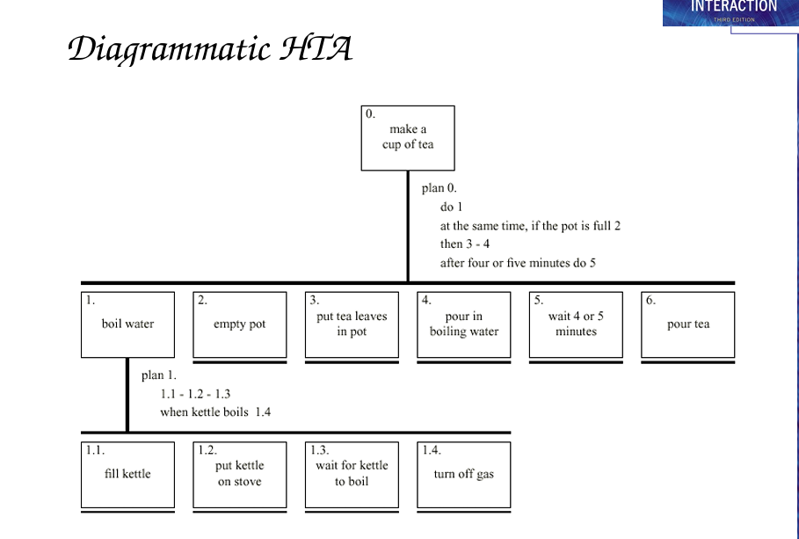

🔹 Slide 13 – Refining the Task Description
After making HTA, improve it by:

Checking missing actions e.g., where is `turn on gas
Combining related tasks e.g generate task `make pot
Balancing task complexity e.g., is `pour tea' simpler than making
Making tasks general (one cup or many)

📌 Goal: clear and realistic HTA
----------------------
🔹 Slide 14 – Refined HTA (Making Tea)
Improved tea-making steps:
- Boil water
- Make tea pot
- Pour tea
- Add milk/sugar if needed
Includes:
- Conditions
- Repeated steps
- Optional steps
📌 Shows real-life task flow

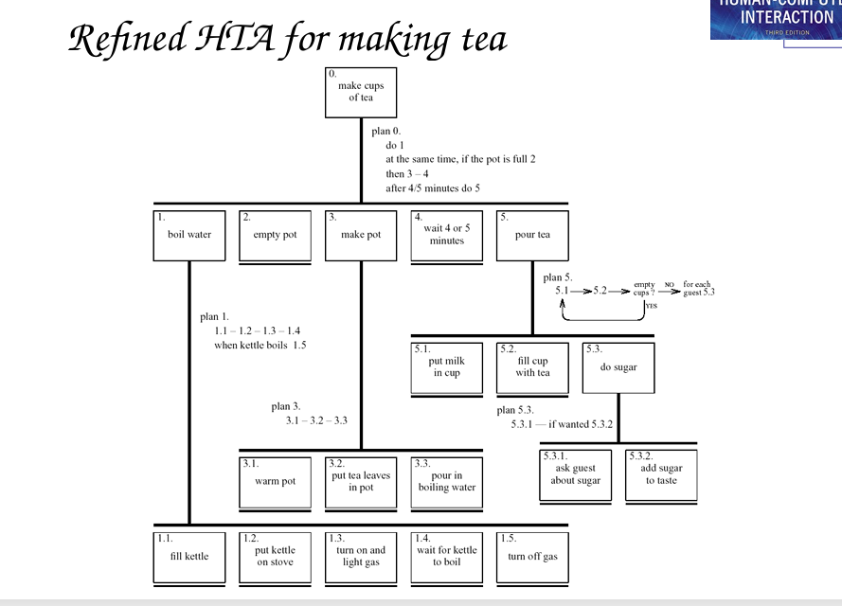

----------------------
🔹 Slide 15 – Types of Plans in HTA
Different ways tasks can flow:
- Fixed order (1.1 then 1.2 then 1.3)
Optional steps (if the pot is full 2 )
- Waiting for events
- Repeating tasks (loops)
Parallel tasks (do 1; at the same )

- Any-order tasks
📌 Real tasks use multiple plan types

🔹 Slide 17 – Worked Exercise
Task:
👉 Create HTA for finding information on a website
Website has:
- Search option
- Normal links
📌 Very common exam/assignment question

🔹 Slide 18 – Knowledge-Based Analysis (KBA)
This slide introduces Knowledge-Based Analysis.
What is KBA?
KBA focuses on:
- Objects → things used in a task
- Actions → things users do
- Taxonomies → organized categories (from simple to detailed)
📌 Unlike HTA (which focuses on steps), KBA focuses on what users KNOW.
----------------------
🔹 Slide 19 – KBA Example (Car Controls)
This slide shows how car controls are organized.
Examples:
- Steering → steering wheel, indicators
- Engine & speed
- Gears → clutch, gear stick
- Lights → headlights, hazard lights
- Wipers & washers
- Heating system
- Parking → hand brake
- Radio
📌 Idea:
User doesn’t think in buttons — they think in functions.
----------------------
🔹 Slide 20 – Task Description Hierarchy (TDH)
TDH is a special taxonomy used in KBA.
Three types of branches:
1️⃣ XOR (Exclusive OR)
- Object belongs to only one category
2️⃣ AND
- Object belongs to multiple categories at same time
3️⃣ OR
- Object may belong to one, many, or none
📌 Helps classify objects clearly.
----------------------
🔹 Slide 21 – Large TDH Example (Kitchen Items)
Objects are classified by:
- Shape (flat, dished)
- Function (preparation, cooking, dining)
Example:
- Plate → flat + dining
- Frying pan → flat + cooking
📌 Shows how one object fits multiple roles.
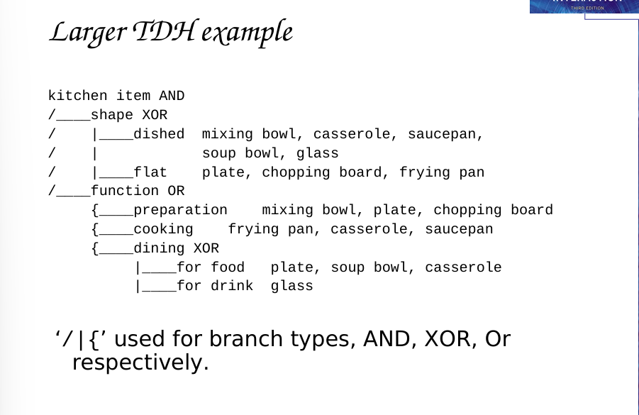
----------------------
🔹 Slide 22 – More on TDH
Uniqueness Rule:
Each object must be uniquely identifiable.
Example:
- Plate =
  - kitchen item
  - flat shape
  - preparation + dining
Also shows Action Taxonomy:
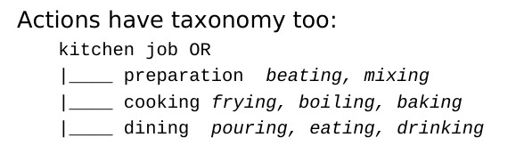
📌 Avoids confusion in design.
----------------------
🔹 Slide 23 – Entity-Relationship Techniques
This technique focuses on:
- Objects
- Actions
- Relationships
Similar to Object-Oriented Analysis, BUT:
- Includes people
- Focuses on real-world domain, not coding
Example system:
👉 Vera’s Veggies (a farming business)
----------------------
🔹 Slide 24 – Objects
Objects are classified into:
1️⃣ Concrete Objects
- Tools, machines, buildings
2️⃣ Actors
- Humans
- Machines (irrigation controller)
3️⃣ Composite Objects
- Groups or combinations
- Example: Team = Vera + Sam + Tony
📌 Machines can also be actors.
----------------------
🔹 Slide 25 – Attributes
Objects have attributes (properties).
Example:
- Object: Pump
- Attributes:
  - Status (on/off/faulty)
  - Capacity (100 litres/min)
📌 Attributes don’t need to be fully technical.
----------------------
🔹 Slide 26 – Actions
Every action has:
- Agent → who does it
- Patient → what is affected
- Instrument → tool used
Example:
- Tony (agent) dug (action) field (patient) using spade (instrument)
📌 Helps understand task responsibility.
----------------------
🔹 Slide 27 – Actions (Continued)
Important concepts:
- Implicit agents
“Field was ploughed” → by whom?
- Indirect agency
Vera programs controller → controller irrigates
- Messages
Vera tells Sam to dig
- Roles
Vera = manager + worker
📌 One person can have many roles.
🔹 Slide 28 – Example: Objects & Actions
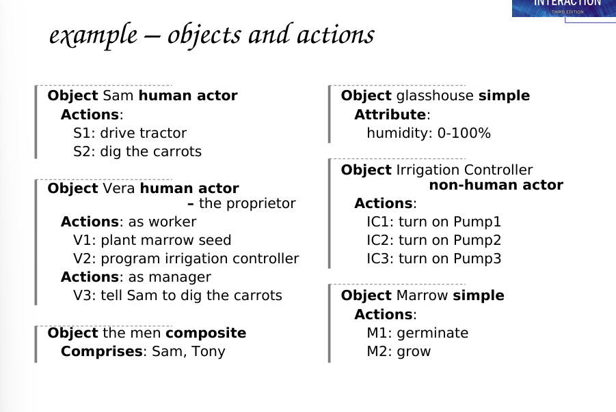
🔹 Slide 29 – Events
Events are things that happen.
Types:
1️⃣ Action events
“Sam dug carrots”
2️⃣ Spontaneous events
“Seed germinated”
3️⃣ Timed events
“At midnight system starts”
📌 Events may trigger actions.
🔹 Slide 30 – Relationships
Types of relationships:
Object–Object
- Social (Sam works under Vera)
- Spatial (pump in glasshouse)
Action–Object
- Agent, patient, instrument
Action–Event
- Cause and effect
- Before / after
📌 Shows how things connect.

🔹 Slide 31 – Example: Events & Relationships
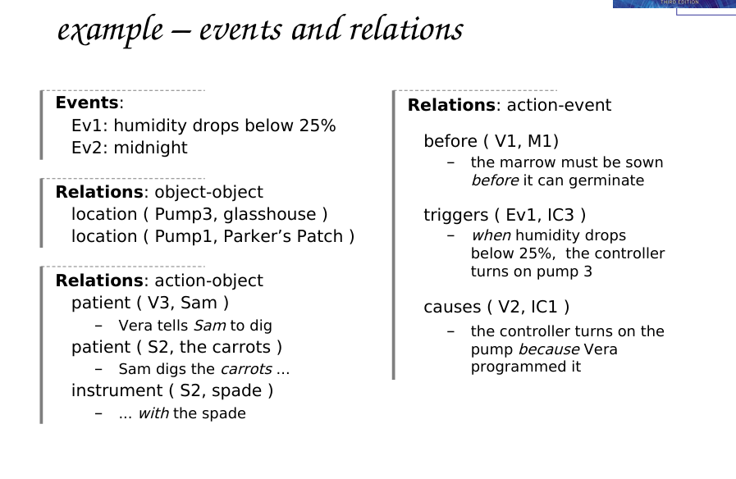
🔹 Slide 32 – Sources of Information
To collect task data:
Documentation (manuals)N.B. manuals say what is supposed to happen but, good for key words and prompting interviews
Observation (watch users) formal/informal, laboratory/field
Interviews (experts & workers) the expert: manager or worker? (ask both!)
📌 Manuals show ideal behavior, not real behavior.
🔹 Slide 33 – Early Analysis
Steps:
- Extract nouns (objects)the rain poured’ vs. `I poured the tea’
- Extract verbs (actions)
- Group and rank them
- Repeat analysis
📌 Iterative process.
🔹 Slide 34 – Uses: Manuals & Documentation
Task Analysis helps create:
Conceptual Manuals
Explain system concept from knowledge or entity–relations based analysis– good for open ended tasks
Procedural Manuals
- Step-by-step instructions
- Best for beginners
📌 HTA is best for “How-to” manuals.
from HTA description– good for novices– assumes all tasks known
🔹 Slide 35 – Uses: Requirements & Design
Task Analysis helps in:
- Requirements gathering
- Interface design
- Menu structure
- Automation decisions
⚠️ Warning:
Task Analysis is never complete
Too rigid design → inflexible system

